**WEEK 7**

Create a React Application named “cricketapp”

Step1:Creating a React Application and navigating into the folder





Step2:Creating the ListofPlayers Component:

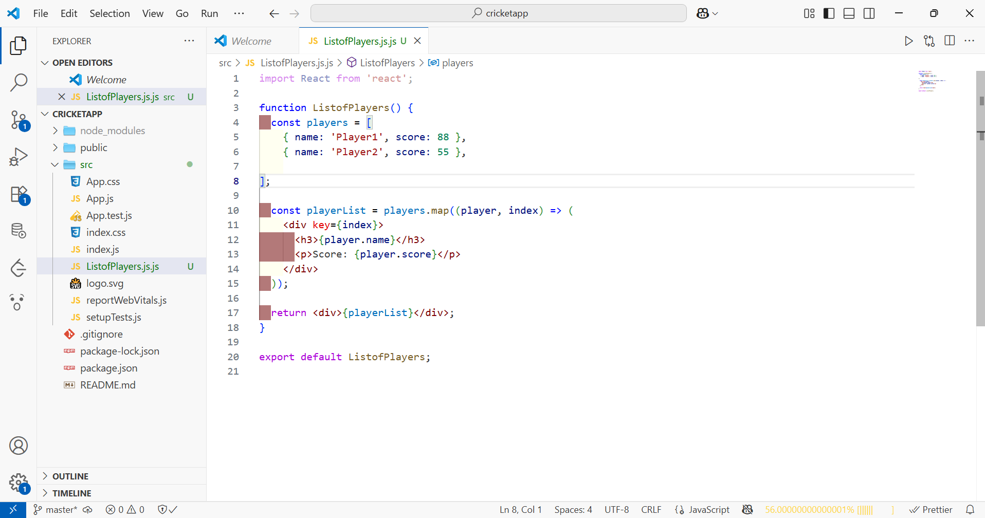

Step3: Filtering Players with Scores Below 70 Using Arrow Functions

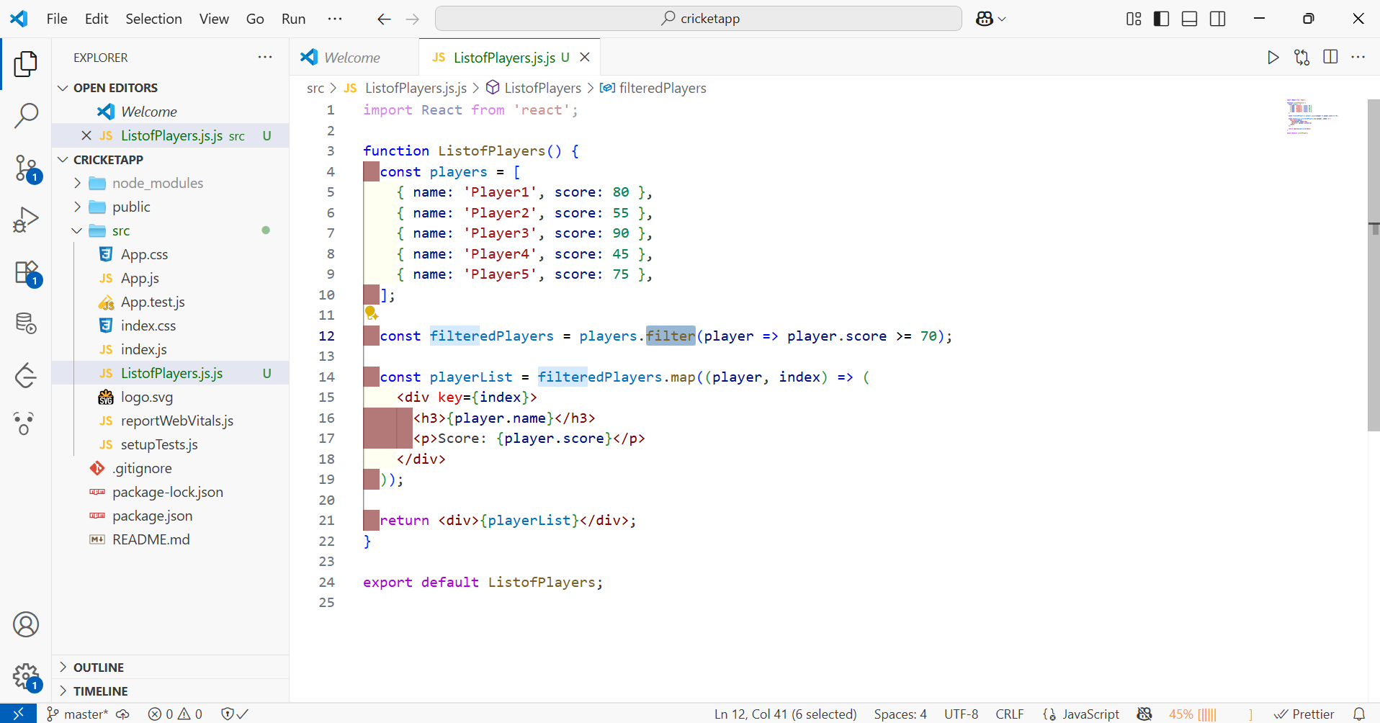

Step4:Create the IndianPlayers Component and add the two arrays

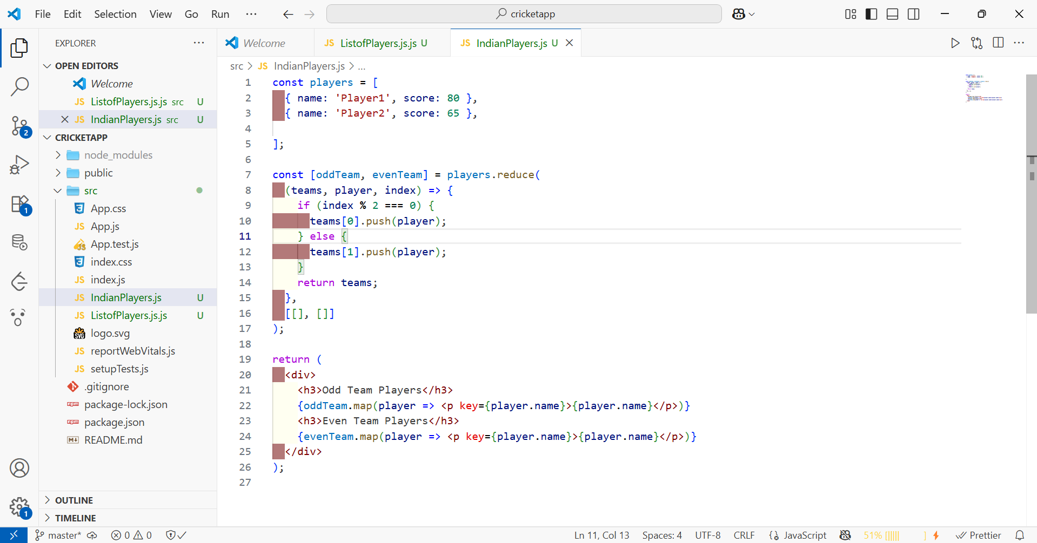

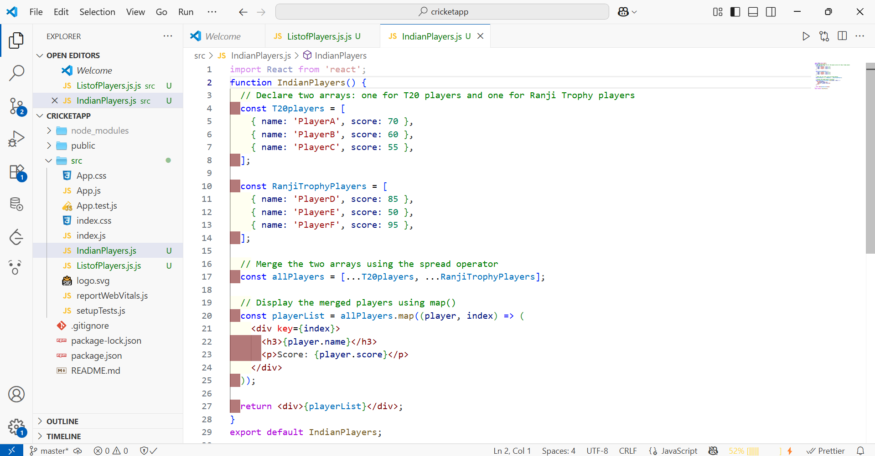

Step5: Controlling Display Using Flag Variable

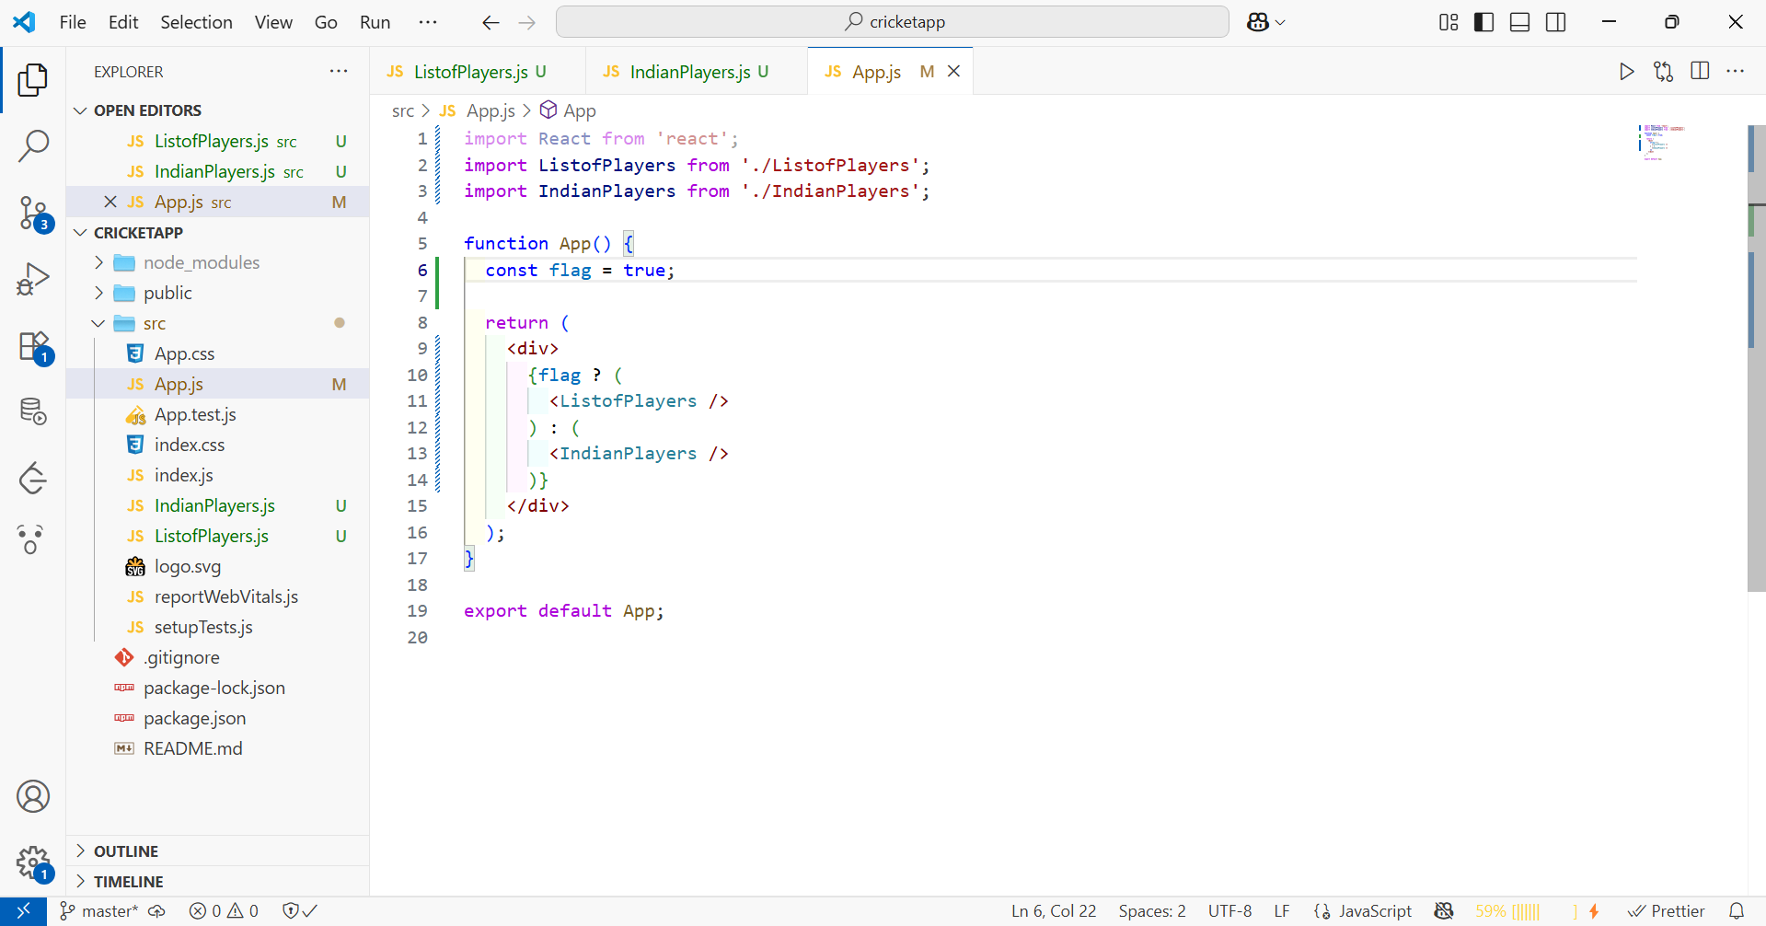

Step6:Running the application



